**PROJECT REPORT TEMPLATE**

**MEASURING THE PULSE OF PROSPERTY : AN INDEX OF ECONOMIC FREEDOM ANALYSIS**

1. **INTRODUCTION:**

Economic freedom is the fundamental right of every human to control his or her own labor and property. In an economically free society, individuals are free to work, produce, consume, and invest in any way they please. In economically free societies, governments allow labor, capital, and goods to move freely, and refrain from coercion or constraint of liberty beyond the extent necessary to protect and maintain liberty itself.For much of human history, most individuals have lacked economic freedom and opportunity, condemning them to poverty and deprivation.Today, we live in the most prosperous time in human history. Poverty, sicknesses, and ignorance are receding throughout the world, due in large part to the advance of economic freedom. In 2022, the principles of economic freedom that have fueled this monumental progress are once again measured in the Index of Economic Freedom, an annual guide published by The Heritage Foundation, Washington's No. 1 think tank.We measure economic freedom based on 12 quantitative and qualitative factors, grouped into four broad categories, or pillars, of economic freedom:

1) Rule of law property rights, government integrity, judicial effectiveness)

2) Government size (government spending, tax burden, fiscal health)

3) Regulatory efficiency (business freedom, labor freedom, monetary freedom)

4) Open markets (trade freedom, investment freedom, financial freedom)

1. **PROBLEMS DEFINITION & DESIGN THINKING:**

EMPATHY MAP: 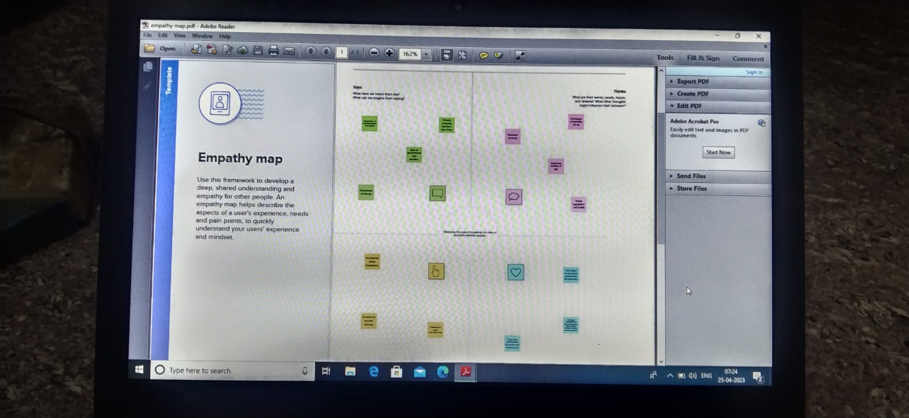

BRAINSTORMING & IDEATION MAP:

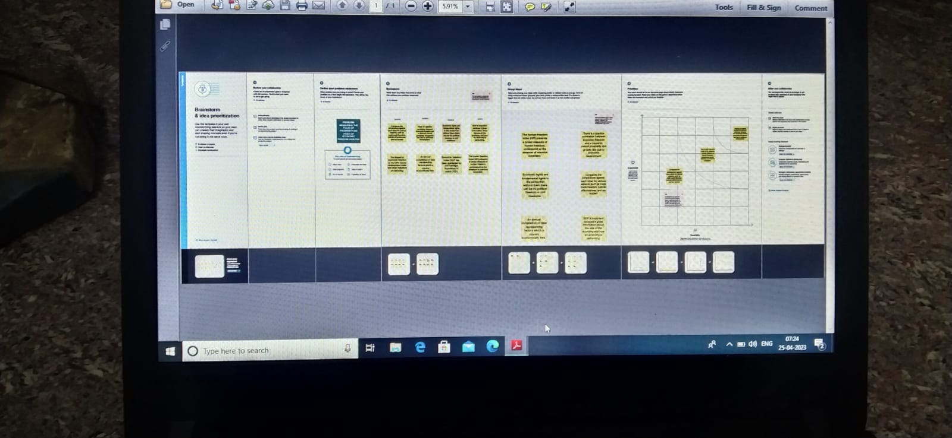

1. **RESULTS:**

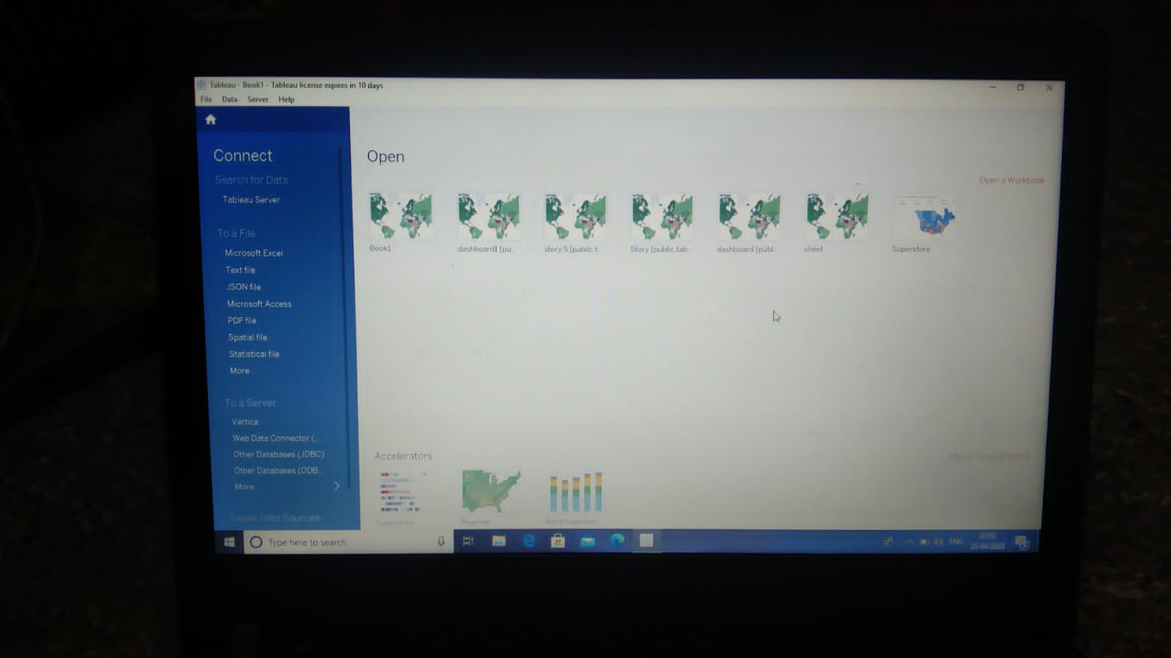

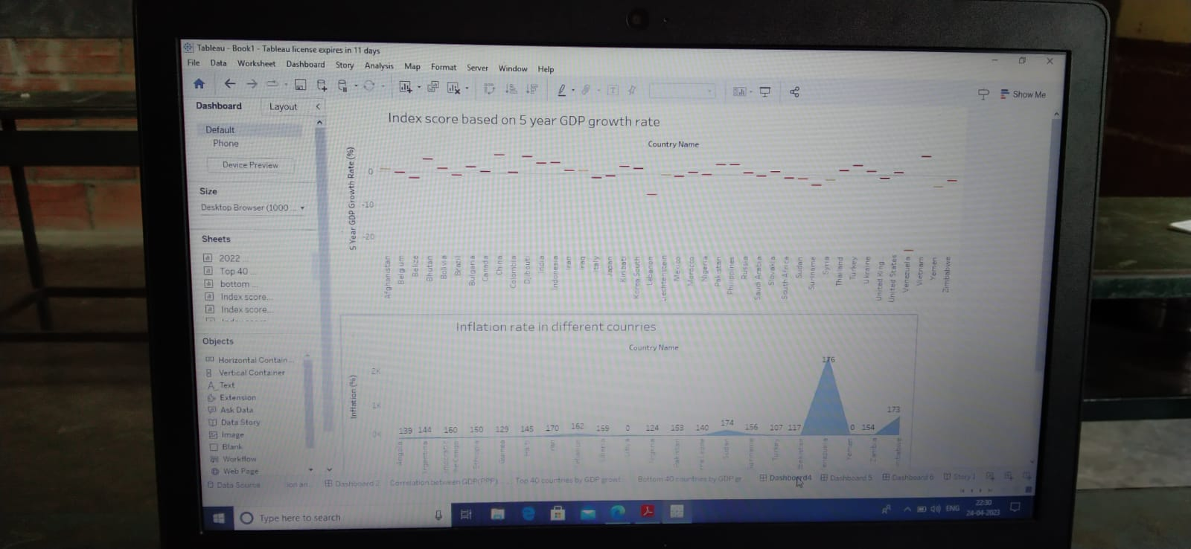

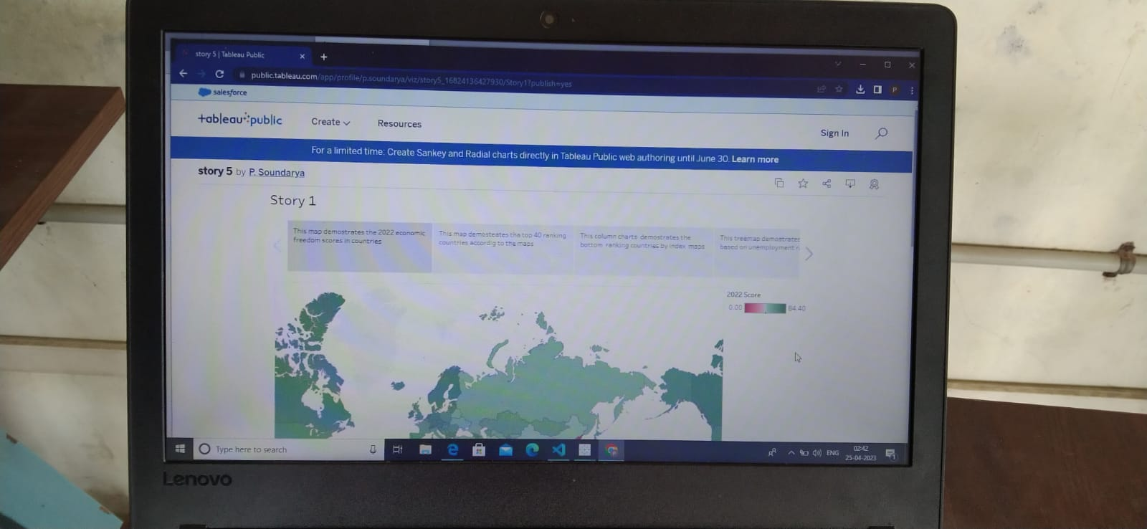



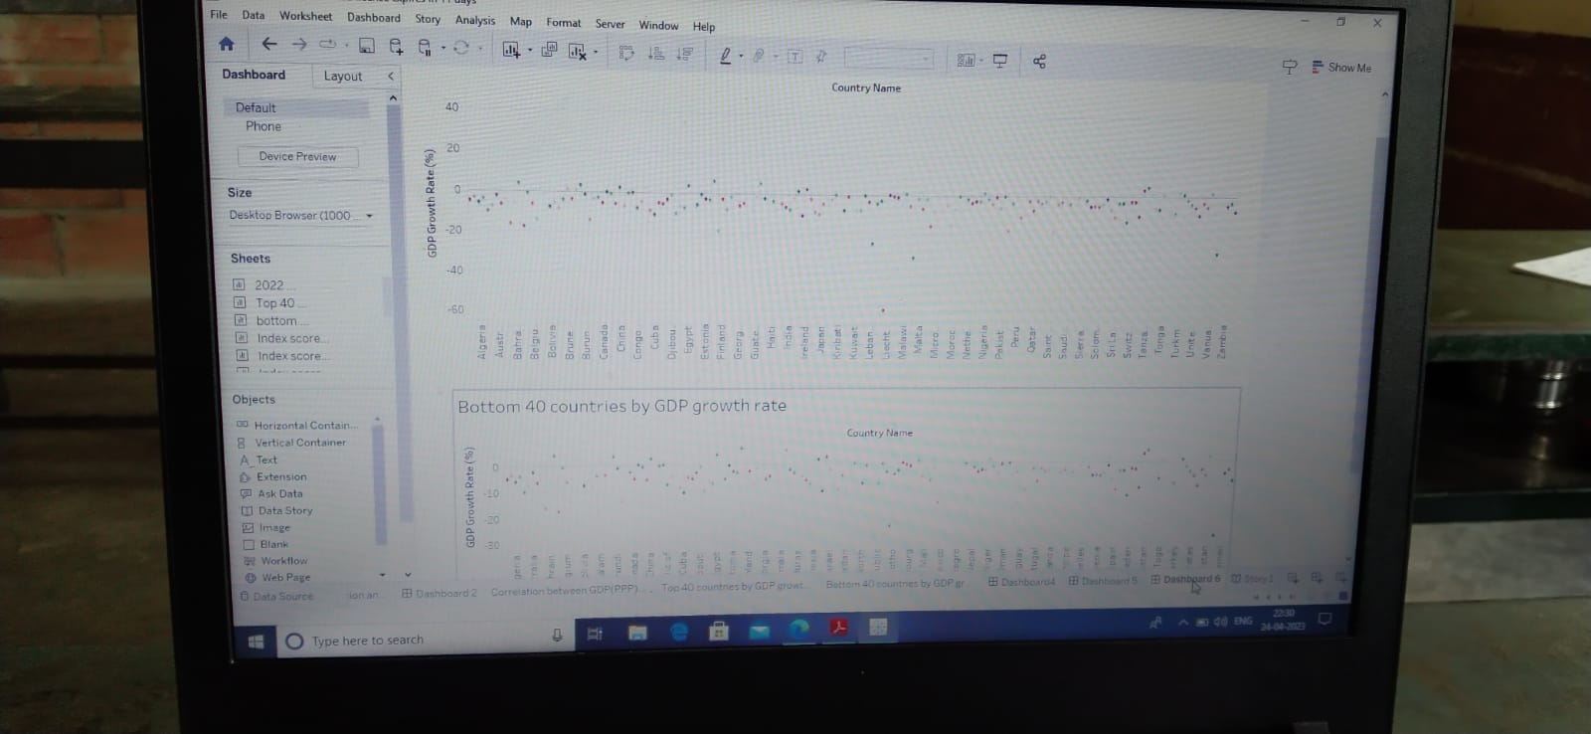

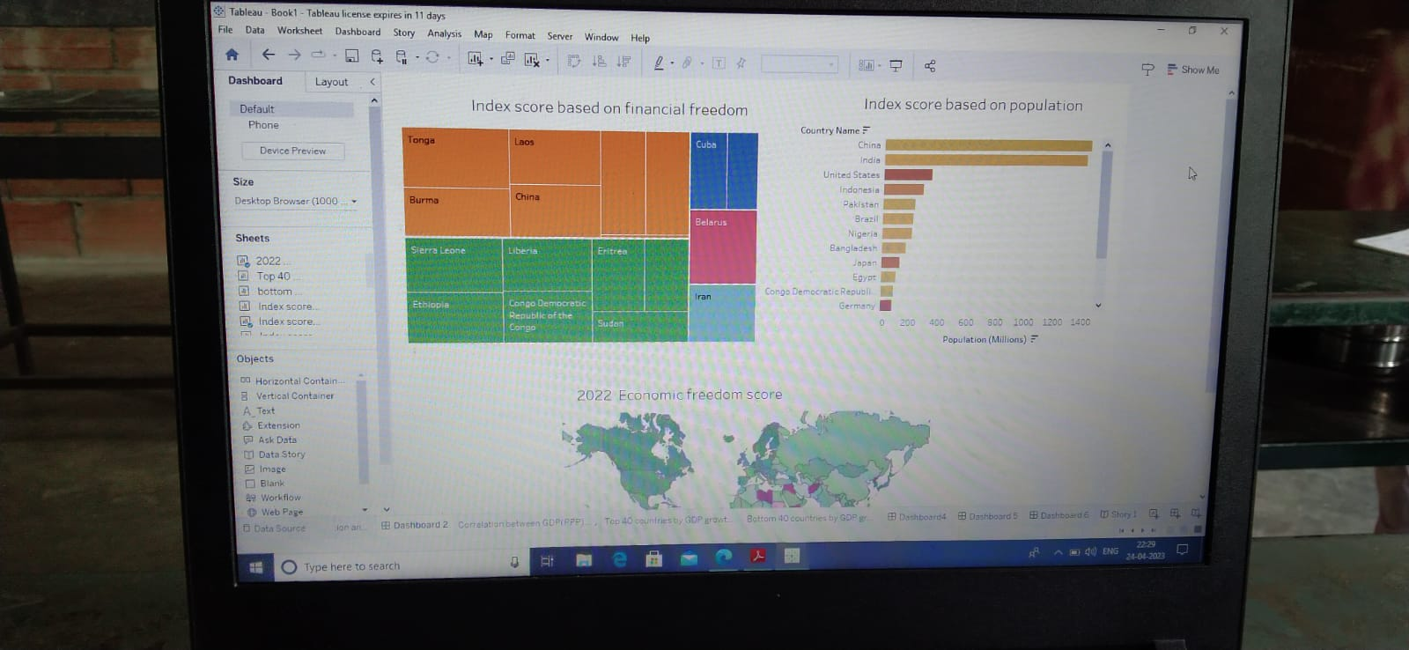

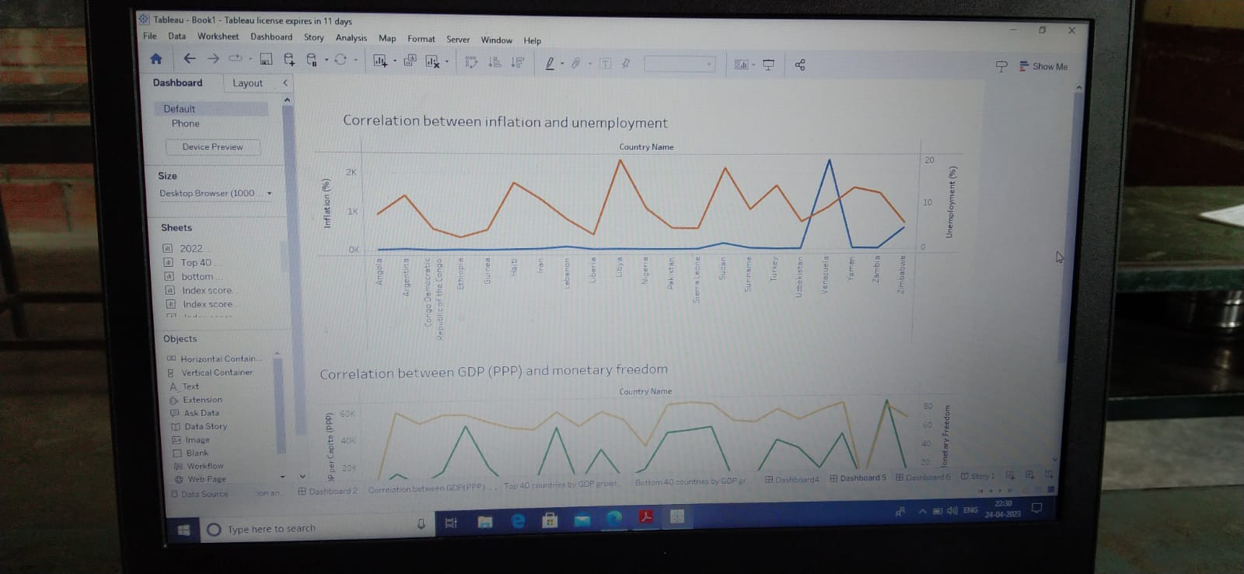

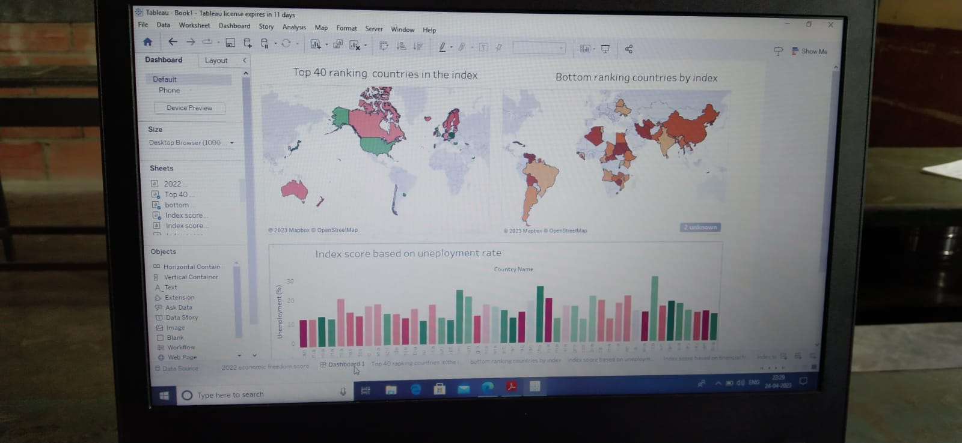

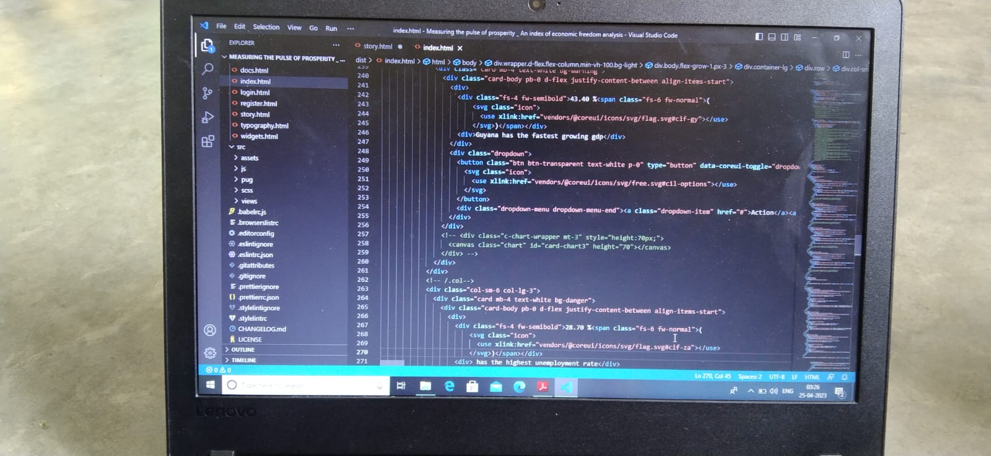

1. **ADVANTAGES & DISADVANTAGES :**

Economic indicators help you consider trades in the context of economic events and understand price actions during these events. You do not need advanced knowledge of economics to make use of an economic calendar, as not every single data release must be analyzed in-depth .By following GDP indicators, for instance, or inflation and employment strength, you can anticipate market volatility and identify potential trading opportunities. You should also know which economic indicators have a greater impact in terms of trading. For example, **leading indicators** change before the economy starts following a trend – they predict economic changes. **Lagging indicators**, on the other hand, change after the economy has already started following a trend – they confirm economic changes.An index of economic freedom measures jurisdictions against each other in terms of parameters such as trade freedom, tax burden, judicial effectiveness, and more. These factors may be weighted according to their influence on economic freedom and compiled into a single score that allows for a ranking. The ranking can be done on a country basis or can look at wider regions or smaller subnational units like states.The most widely referenced index of economic freedom is produced by the Heritage Foundation, a conservative American think tank. The Fraser Institute, a Canadian think tank, also publishes a well-known index of economic freedom.

1. **APPLICATIONS:**

GDP is important because it gives information about the size of the economy and how an economy is performing. The growth rate of real GDP is often used as an indicator of the general health of the economy. In broad terms, an increase in real GDP is interpreted as a sign that the economy is doing well.An index of economic freedom measures jurisdictions against each other in terms of parameters such as trade freedom, tax burden, judicial effectiveness, and more. These factors may be weighted according to their influence on economic freedom and compiled into a single score that allows for a ranking.

1. **CONCLUSION:**

The index of economic freedom is one of several metrics for comparing different economic regimes. Although the Heritage Foundation publishes the most widely-used economic freedom index, there are several institutions that publish their own versions. Each of them seeks to quantify elements such as regulation, taxation, government interference, and price controls, which represent constraints on free enterprise and market activity.

1. **FUTURE SCOPE:**

The latest edition of the heritage index omitted two regions that had previously ranked close to the top by economic freedom: Hong Kong and Macau. Hong Kong had previously held the number one spot for 25 years, before being bumped by Singapore in 2020 due to perceptions of [tightening control](https://www.investopedia.com/why-hong-kong-needs-autonomy-to-be-a-global-financial-hub-4690553) by the mainland Chinese government. In a note accompanying the 2021 Index, the Heritage Foundation explained that Hong Kong was left out, so that the index would only cover places "where governments exercise sovereign control of economic policies." Although both regions continue to enjoy advantageous policies, the Foundation explained, "those policies are ultimately controlled from Beijing."Hong Kong officials objected to the omission, calling the assertion of Beijing's control "ill-conceived and untrue."